For Immediate Release: 11/05/2015
Contact: Darin Evans
darin.evans@ecoological.com
916.663.9198
www.ecoological.com/bumpershellz.html
BumperShellz™ – First Implementation for Front Truck Bumpers on 2014-Present Chevy Silverado
eCOOLogical, Newcastle, California, launches its first implementation of their patent-pending BumperShellz™ truck bumper covers for front bumpers on the 2014-present Chevrolet Silverado 1500. This new multi-piece design makes installation over the original equipment bumper incredibly quick and easy, allowing truck owners to add new styling to their trucks with a matching front/rear BumperShellz™ set!
Today's OE truck bumpers are made from thin, low strength steel, thus vulnerable to damage. Replacement OE front bumpers can typically run over $1000 in parts, plus several hours of labor. Truck owners can now avoid the high cost of repair/replacement by covering minor damage/rust from road debris, salt/snow and protect truck value by reducing occurrence of bumper damage with these stylish and durable covers.
BumperShellz are made from High Impact ABS plastic with pre-laminated paint film and additional scratch/UV resistant clear coat film, making them very durable. Available for with/without fog lamp bumpers. With fog lamp may include standard trim bezel or optional backlit version.
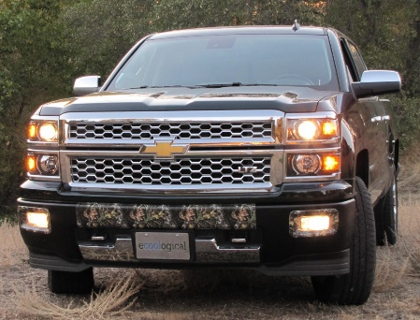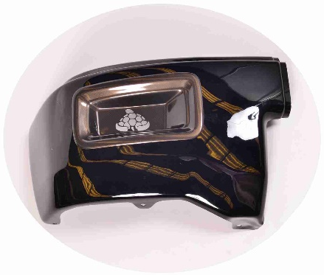
In addition to the new implementation for the front bumper of the 2014-present Chevy Silverado 1500, ecoological currently manufactures BUMPERSHELLZ™ for the rear bumpers of the ‘07-‘16 GM Silverado and Sierra LD and HD models, ‘09-‘14 Ford F150, ‘09-‘14 Ram trucks, and ’05-’15 Toyota Tacoma, with other models to follow.
Visit us at SEMA 2015 in the Trucks, SUVs, and Off-road section, booth #34236, located in the upper south hall.
To access additional high-resolution BUMPERSHELLZ™ examples, please visit:
http://www.ecoological.com/bumpershellz-front-bumper-2015-sema-press-release.html
About ecoological:
Based in Newcastle, CA, ecoological thrives on bringing innovative product solutions to our customers that enhance their vehicles and eliminate everyday automotive headaches. All ecoological products are proudly manufactured in the USA with emphasis on environmentally friendly materials, processes, and designs. To learn more about ecoological and our products, please visit: http://www.ecoological.com

