For Immediate Release: 11/04/2015
Contact: Darin Evans
darin.evans@ecoological.com
916.663.9198
www.ecoological.com/bumpershellz.html
ToughShellz™ – Protective Truck Bumper Covers
eCOOLogical, Newcastle, California, introduces ToughShellz™, a new addition to the patent-pending BumperShellz™ line of truck bumper covers. ToughShellz™ are made especially for truck owners that work their truck hard. These durable covers are made from a textured, molded-in color UV resistant black, high-impact ABS plastic. This construction provides terrific resistance to minor impacts and abrasion, thus an effective protective shell for vulnerable OEM truck bumpers. Whether protecting from snow and ice, or from road debris kicked up on the trail, ToughShellz™ will help keep your bumper looking great. Had a little mishap with your bumper before you learned about ToughShellz™? Don’t worry, ToughShellz™ can often cover existing minor damage and/or rust . . . like it never happened! BumperShellz™, including the new ToughShellz™ version, install easily over original equipment bumpers and are now available for rear bumpers of many late model pickup trucks.

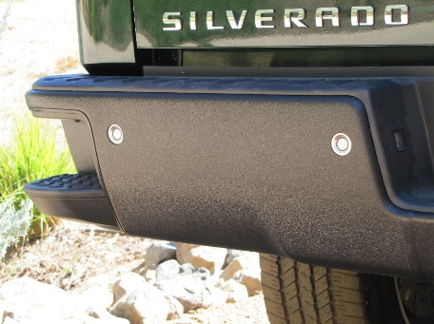

ecoological currently manufactures BUMPERSHELLZ™ for the rear bumpers of the ‘07-‘16 GM Silverado and Sierra LD and HD models, ‘09-‘14 Ford F150, ‘09-‘14 Ram trucks, and ’05-’15 Toyota Tacoma, with other models to follow.
Visit us at SEMA 2015 in the Trucks, SUVs, and Off-road section, booth #34236, located in the upper south hall.
To access additional high-resolution BUMPERSHELLZ™ examples, please visit:
http://www.ecoological.com/BUMPERSHELLZ-2015-SEMA-Press Release.html
About ecoological:
Based in Newcastle, CA, ecoological thrives on bringing innovative product solutions to our customers that enhance their vehicles and eliminate everyday automotive headaches. All ecoological products are proudly manufactured in the USA with emphasis on environmentally friendly materials, processes, and designs. To learn more about ecoological and our products, please visit: http://www.ecoological.com

